The biggest threat facing middle-age men isn’t smoking or obesity. It’s loneliness.

As men grow older, they tend to let their friendships lapse. But there’s still time to do something about it.
By Billy BakerMarch 9, 2017, 8:58 a.m.

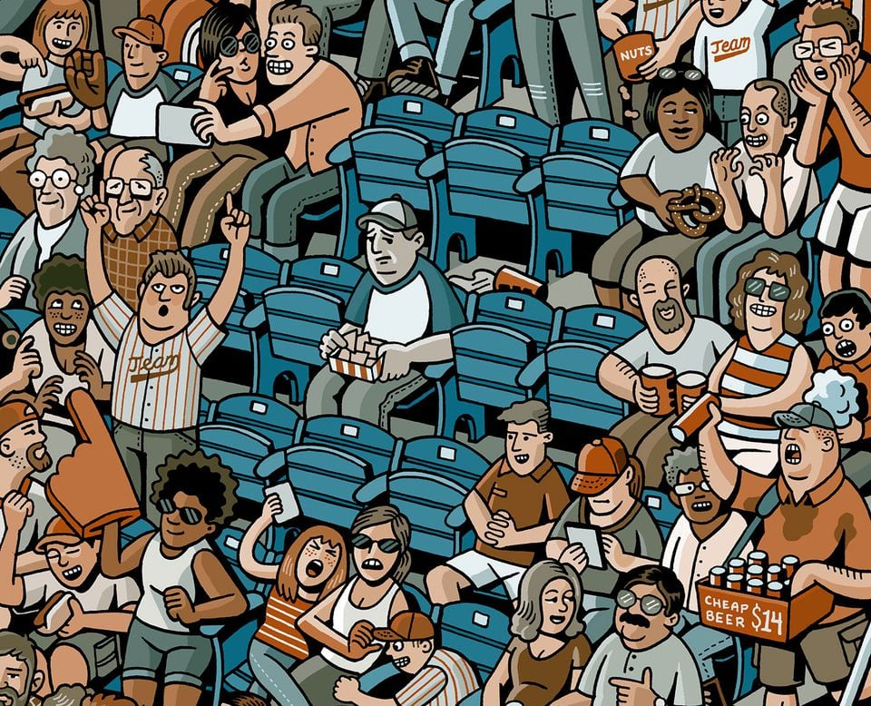MARIO ZUCCA FOR THE BOSTON GLOBE
LET’S START WITH THE MOMENT I realized I was already a loser, which was just after I was more or less told that I was destined to become one.
I’d been summoned to an editor’s office at the Globe Magazine with the old “We have a story we think you’d be perfect for.” This is how editors talk when they’re about to con you into doing something you don’t want to do.
Here was the pitch: We want you to write about how middle-aged men have no friends.
Excuse me? I have plenty of friends. Are you calling me a loser? You are.
The editor told me there was all sorts of evidence out there about how men, as they age, let their close friendships lapse, and that that fact can cause all sorts of problems and have a terrible impact on their health.
I told the editor I’d think about it. This is how reporters talk when they’re trying to get out of something they don’t want to do. As I walked back to my desk in the newsroom — a distance of maybe 100 yards — I quickly took stock of my life to try to prove to myself that I was not, in fact, perfect for this story.
Get Globe Magazine
An engaging blend of award-winning narrative journalism, opinion, lifestyle, travel, recipes, and advice.
Enter Email
Sign Up
First of all, there was my buddy Mark. We went to high school together, and I still talk to him all the time, and we hang out all the . . . Wait, how often do we actually hang out? Maybe four or five times a year?
And then there was my other best friend from high school, Rory, and . . . I genuinely could not remember the last time I’d seen him. Had it already been a year? Entirely possible.
There were all those other good friends who feel as if they’re still in my lives because we keep tabs on one another via social media, but as I ran down the list of those I’d consider real, true, lifelong friends, I realized that it had been years since I’d seen many of them, even decades for a few.
By the time I got back to my desk, I realized that I was indeed perfect for this story, not because I was unusual in any way, but because my story is very, very typical. And as I looked into what that means, I realized that in the long term, I was heading down a path that was very, very dangerous.
Vivek Murthy, the surgeon general of the United States, has said many times in recent years that the most prevalent health issue in the country is not cancer or heart disease or obesity. It is isolation.
I TURNED 40 IN MAY. I have a wife and two young boys. I moved to the suburbs a few years ago, where I own a fairly ugly home with white vinyl siding and two aging station wagons with crushed Goldfish crackers serving as floor mats. When I step on a Lego in the middle of the night on my way to the bathroom, I try to tell myself that it’s cute that I’ve turned into a sitcom dad.
During the week, much of my waking life revolves around work. Or getting ready for work. Or driving to work. Or driving home from work. Or texting my wife to tell her I’m going to be late getting home from work.
Much of everything else revolves around my kids. I spend a lot of time asking them where their shoes are, and they spend a lot of time asking me when they can have some “dada time.” It is the world’s cutest phrase, and it makes me feel guilty every time I hear it, because they are asking it in moments when they know I cannot give it to them — when I am distracted by an e-mail on my phone or I’m dealing with the constant, boring logistics of running a home.
We can usually squeeze in an hour of “dada time” before bed — mostly wrestling or reading books — and so the real “dada time” happens on weekends. That’s my promise. “I have to go to work, but this weekend,” I tell them, “we can have ‘dada time.’ ”
I love “dada time.” And I’m pretty good about squeezing in an hour of “me time” each day for exercise, which usually means getting up before dawn to go to the gym or for a run. But when everything adds up, there is no real “friend time” left. Yes, I have friends at work and at the gym, but those are accidents of proximity. I rarely see those people anywhere outside those environments, because when everything adds up, I have left almost no time for friends. I have structured myself into being a loser.
“YOU SHOULD USE THIS story suggestion as a call to do something about it.”
That’s Dr. Richard S. Schwartz, a Cambridge psychiatrist, and I had reached out to him because he and his wife, Dr. Jacqueline Olds, literally wrote the book on this topic, The Lonely American: Drifting Apart in the Twenty-First Century.
He agreed that my story was very typical. When people with children become overscheduled, they don’t shortchange their children, they shortchange their friendships. “And the public health dangers of that are incredibly clear,” he says.
Beginning in the 1980s, Schwartz says, study after study started showing that those who were more socially isolated were much more likely to die during a given period than their socially connected neighbors, even after you corrected for age, gender, and lifestyle choices like exercising and eating right. Loneliness has been linked to an increased risk of cardiovascular disease and stroke and the progression of Alzheimer’s. One study found that it can be as much of a long-term risk factor as smoking.
The research doesn’t get any rosier from there. In 2015, a huge study out of Brigham Young University, using data from 3.5 million people collected over 35 years, found that those who fall into the categories of loneliness, isolation, or even simply living on their own see their risk of premature death rise 26 to 32 percent.
Now consider that in the United States, nearly a third of people older than 65 live alone; by age 85, that has jumped to about half. Add all of this up, and you can see why the surgeon general is declaring loneliness to be a public health epidemic.
“Since my wife and I have written about loneliness and social isolation, we see a fair number of people for whom this is a big problem,” Schwartz continues. But there’s a catch. “Often they don’t come saying they’re lonely. Most people have the experience you had in your editor’s office: Admitting you’re lonely feels very much like admitting you’re a loser. Psychiatry has worked hard to de-stigmatize things like depression, and to a large part it has been successful. People are comfortable saying they’re depressed. But they’re not comfortable saying they’re lonely, because you’re the kid sitting alone in the cafeteria.”
I’m not that kid. I’m gregarious. I have family around me all the time, or I’m around “friends” at work or elsewhere. I comment on their Facebook posts. They comment on mine. My wife and I also have other couples we like and see often. It’s easy to fall into the trap of believing that’s good enough — and for many men it is, at least until their spouse gets the friends in the divorce.
I’m hesitant to say I’m lonely, though I’m clearly a textbook case of the silent majority of middle-aged men who won’t admit they’re starved for friendship, even if all signs point to the contrary. Now that I’ve been forced to recognize it, the question is what to do about it. Like really do about it. Because the tricks I’ve been using clearly do not work. I’ve been on “guy dates” with people I like — maybe I met them through my kids or on an assignment or whatever — but all too often those are one and done. It’s not that we don’t hit it off. We’ll go have that beer, and we’ll spend that beer talking about how we’re overscheduled and never get to hang with our friends, vaguely making plans to do something again, though we both know it’s probably not going to happen — certainly not the grand “Let’s hike the Appalachian Trail” ideas that start getting thrown out after the third beer. It’s a polite way of kicking the ball down the road, but never into the goal. I like you. You like me. Is that enough? Does that make us friends?
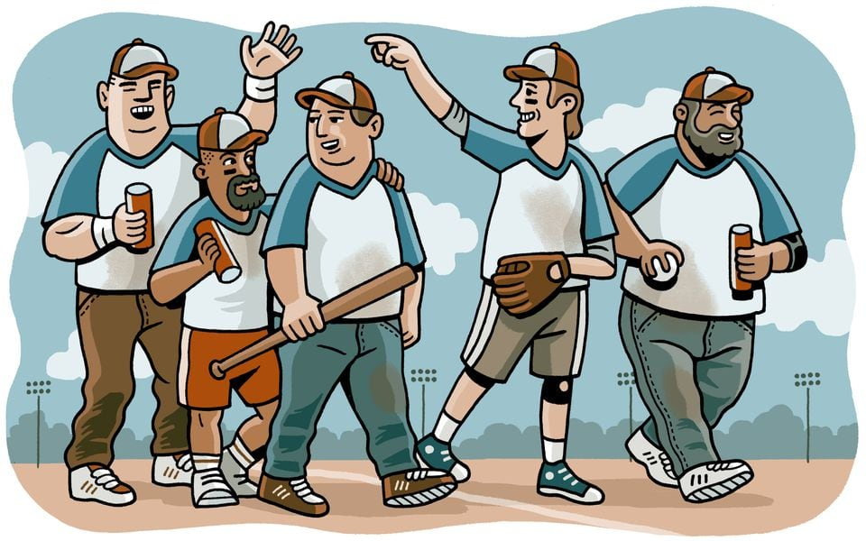MARIO ZUCCA FOR THE BOSTON GLOBE
IN FEBRUARY AT A CONFERENCE in Boston, a researcher from Britain’s University of Oxford presented study results that most guys understand intuitively: Men need an activity together to make and keep a bond. Women can maintain friendships over the phone. My wife is capable of having long phone talks with her sister in Virginia or her friend Casey (whom she sees in person almost every day), and I kind of look at it with amazement. I hate the phone. My guy friends seem to share my feelings, because our phone conversations seem to naturally last about five minutes before someone says, “All right, I’ll catch up with you later.” Dudes aren’t going to maintain a bromance that way, or even over a once-in-a-blue-moon beer. We need to go through something together. That’s why, studies have shown, men tend to make their deepest friends through periods of intense engagement, like school or military service or sports. That’s how many of us are comfortable.
When I was talking to Richard Schwartz, the psychiatrist told me something that had me staring off into the distance and nodding my head. Researchers have noticed a trend in photographs taken of people interacting. When female friends are talking to each other, they do it face to face. But guys stand side by side, looking out at the world together.
But in the middle years of life, those side-by-side opportunities to get together are exactly the sort of things that fall off. When you have a gap in your schedule, you feel bad running off with the fellas and leaving your partner alone to look for the shoes. And the guys I’d like to spend time with are all locked in the exact same bind as me. Planning anything takes great initiative, and if you have to take initiative every time you see someone, it’s easy to just let it disappear.
That’s why Schwartz and others say the best way for men to forge and maintain friendships is through built-in regularity — something that is always on the schedule. This worked well for me over the past year (however unintentionally) with a college buddy named Matt. We signed up to run last April’s Boston Marathon together, and even though he lives in Chicago, we were in regular contact about our training, his trip to Boston, etc., and our relationship became stronger than ever, even though our best and deepest conversation occurred during the four-plus hours it took us to get from Hopkinton to Boston, side by side. We repeated the process with the Chicago Marathon in October, this time in less than four hours (thank God for the flat Midwest), but we haven’t had much contact since then, because we’re no longer going through anything together. I texted him to congratulate him after the Cubs won the World Series. He did the same for me after the Patriots won the Super Bowl. But I can’t remember the last time I talked to Matt since. We have no further plans. That would take initiative.
WHENEVER THE POWERBALL or Mega Millions gets over $100 million, I’ll buy a ticket. My wife thinks I’m nuts, that I’m just wasting our money. I tell her she’s missing the point. I know I’m not going to win, but in that time between when I buy the ticket and the TV news trucks do not show up outside my home, my fantasy brain answers a question for me: What would I really do if I didn’t have to do all this other stuff?
For a while, this was an escape fantasy that involved loading my family into an old Volkswagen bus, hitting the road, and setting off to look for America. That ended when I actually managed to save up enough money to buy an old Volkswagen bus, an endeavor that did not lead to a tour of this country’s national parks but of its auto repair shops. The bus is gone. And so is the escape fantasy. I’m very happy in my life. If I need someone to confide in, I have my wife. All the pieces are here, except one — the guys. I’d like to think they’re also missing me and are just locked into this same prison of commitments. But I don’t want to wait until we’re all retired and can reconnect on a golf course. It feels silly to wait that long, and thanks to this stupid story, I know it’s quite dangerous. So I’m ready to steal a simple concept that doesn’t require lottery money.
A few years ago, shortly after I’d moved from the city to Cape Ann on the North Shore, I took a kayaking class run out of a shop in Essex. At some point, the man who owned the place, an older guy named Ozzy, said something in passing about how he couldn’t do something because he had “Wednesday night.” Slightly confused, I asked him what he was talking about, and he explained an idea to me that was so simple and profound that I resolved one day to steal it . . . when I got older. I think it’s time to admit I’m there.
“Wednesday night,” Ozzy explained, was a pact he and his buddies had made many years before, a standing order that on Wednesday nights, if they were in town, they would get together and do something, anything.
Everything about the idea seemed quaint and profound — the name that was a lack of a name (such a guy move); the placement in the middle of the week; the fact that they’d continued it for so long. But most of all, it was the acknowledgment from male friends that they needed their male friends, for no other reason than they just did.
I tried to reach Ozzy, but he takes the winters off to go skiing in California and the number I had was disconnected. When I tried to get an e-mail address from a mutual friend, I was told he didn’t do e-mail. This guy seems like he has some things figured out. So, Ozzy, I’m stealing Wednesday night.
Obviously, it’s not going to work every time, but experts say that even the act of trying to increase your friendships can benefit your health, so consider this the beginning of that. I’m OK with admitting I’m a little lonely. Doesn’t make me a loser. Doesn’t make you a loser.
Fellas, what are you doing this Wednesday? And the one after that? And the one after that? Consider it a standing invitation. Let’s do something together.

